SUN AND EARTH

-Anonymous

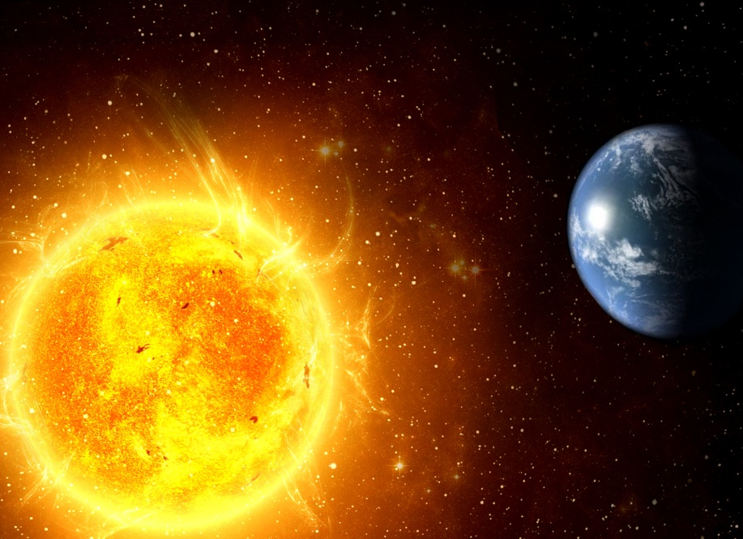

Sun shines bright, over his earth bride.  
Its valour so rich, brilliance so high  
Earth ends up supporting mere life.  
Sun so high; earth so down.  
Yet affectionate, they watch their distant mate.   
Could never meet, for his touch shall burn his bride  
Watches, shining bright.

Causes winds and rains for life to exist.  
Earth's dearest, to over shine its mist.  
For the sun never turns rude, never expressing its solitude.  
Never says, “Sweetheart, you owe me.”  
Sun so high, earth so down.  
Yet affectionate watch their distant mate.

Earth's million stars, Sun's faithful planets.  
Have both chosen to love each other yet?

Sun's hot day and stars' beautiful night, what do you choose dear Earth?  
One means fury, other stays calm.  
One nurtures life, other no harm.  
Sun lets your hand aclasp, thus you wear night.  
Night coats from heat, so you not burn with Sun's bright.  
Affectionate, they watch their distant mate.

